- Linear

1. Determine the inequalities that represent and satisfies the unshaded region (3 mks)
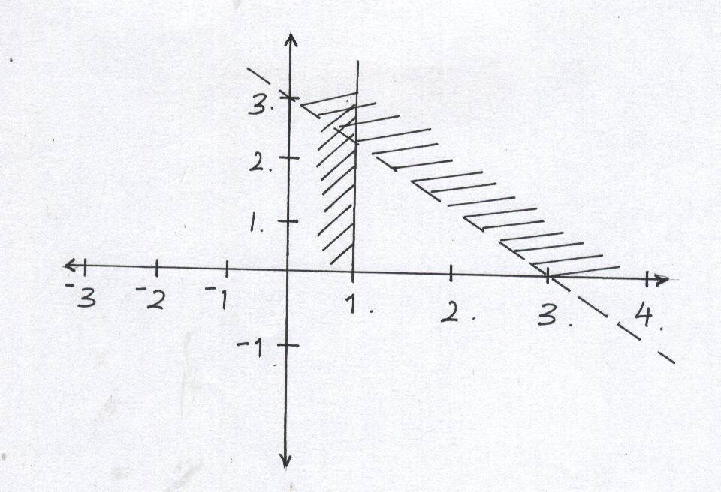
2. Write down the inequalities that satisfy the u shaded region in the figure below. (4mks)
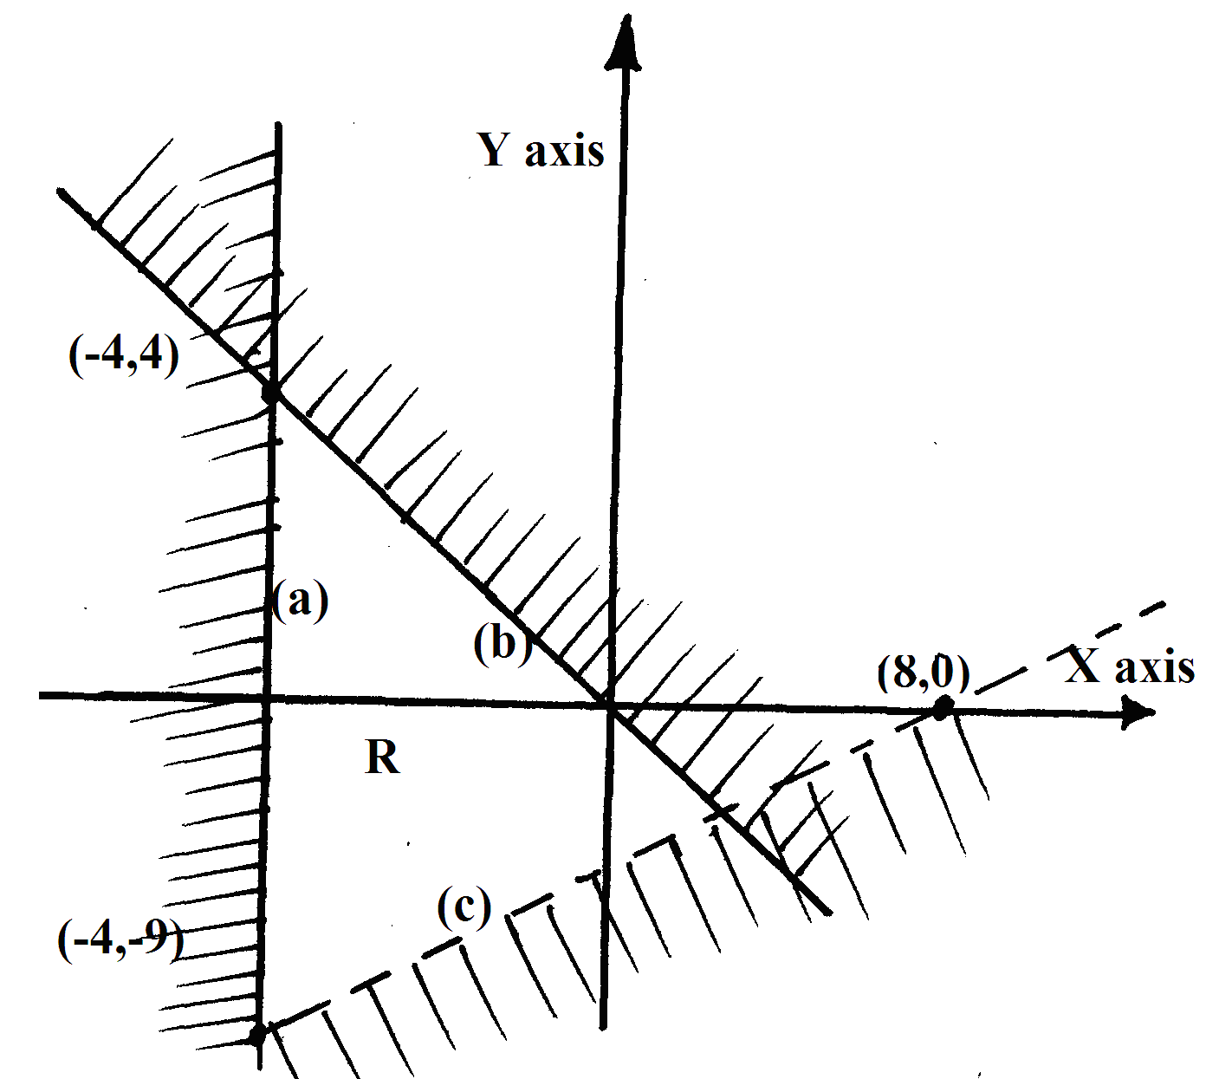

3. Find all integral values that satisfy the inequality 2x + 3 ≥ 5x – 3 > -8. (3mks)
4. a) Find the range of values x which satisfied the following inequalities simultaneously. (2 mks)
4x – 9 < 6 + x
8 – 3x < x + 4
b) Represent the range of values of x on a number line. (1 mark)
5. Solve the inequality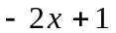<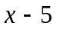<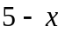 (2mks)
6. (a) Show by shading the unwanted region the area represented by 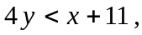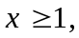 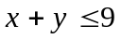and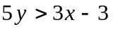 on the grid provided (8 mks)
(b) Calculate the area of the enclosed region (2 mks)
7. Solve the inequality below and write down the integral values that satisfy the equality -3x + 2 < x + 6 ≤ 17 – 2x (3 mks)
8. State all the integral values of a which satisfy the inequality
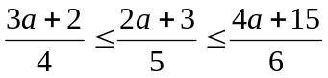 (3mks)
9. Solve the inequality ½ x -2 ≤ 3x – 2 <2 + ½ x and state the integral values which satisfy this inequalities. (3 marks)
10. Write down the inequalities that satisfy the given region simultaneously. (3mks)
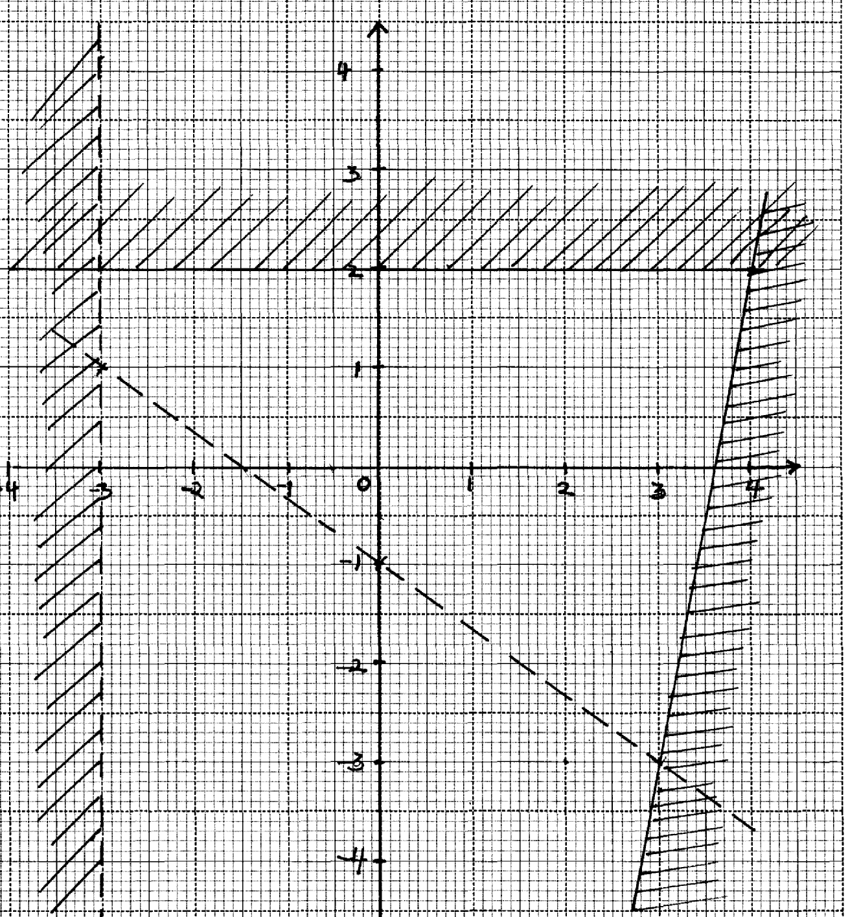

11. Write down the inequalities that define the unshaded region marked R in the figure below. (3mks)
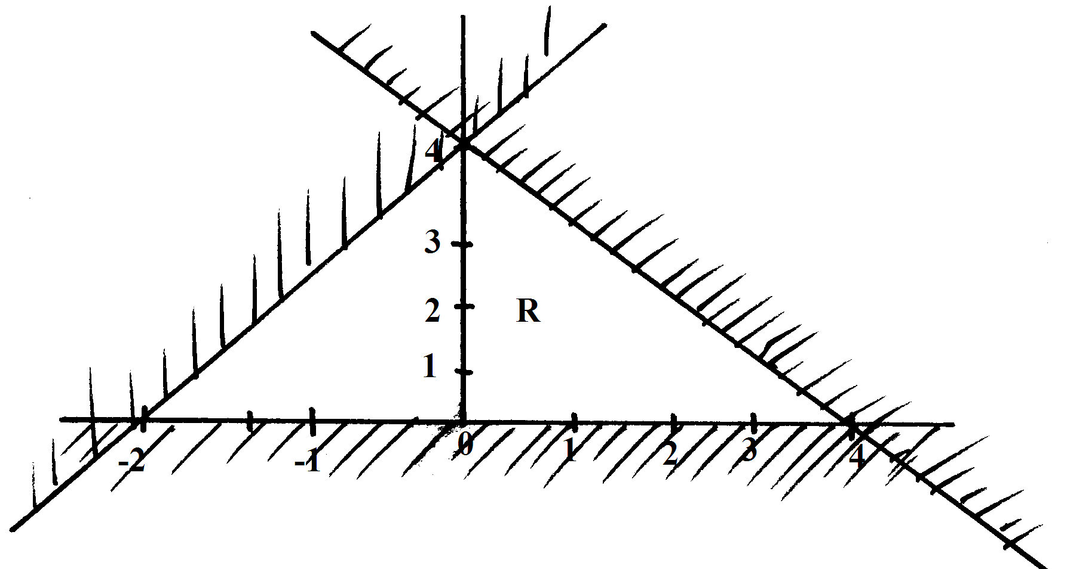
12. Write down all the inequalities represented by the regions R. (3mks)
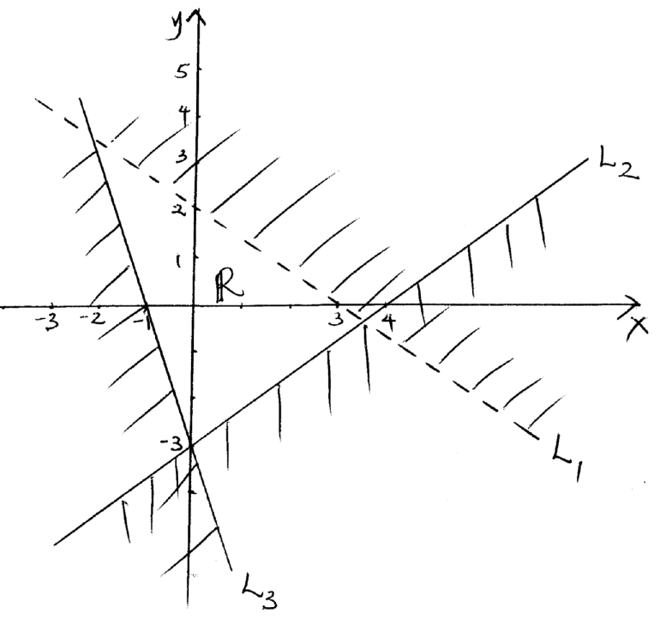
13. a) On the grid provided draw the graph of y = 4 + 3x – x² for the integral values
of x in the interval -2 ≤ X ≤ 5. Use a scale of 2cm to represent 1 unit on the x – axis and 1
cm to represent 1 unit on the y – axis. (6mks)
b) State the turning point of the graph. (1mk)
c) Use your graph to solve.
(i) -x² + 3x + 4 = 0
(ii) 4x = x² (3mks)

14. Solve the following inequality (3 marks)
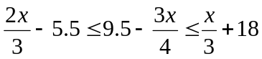

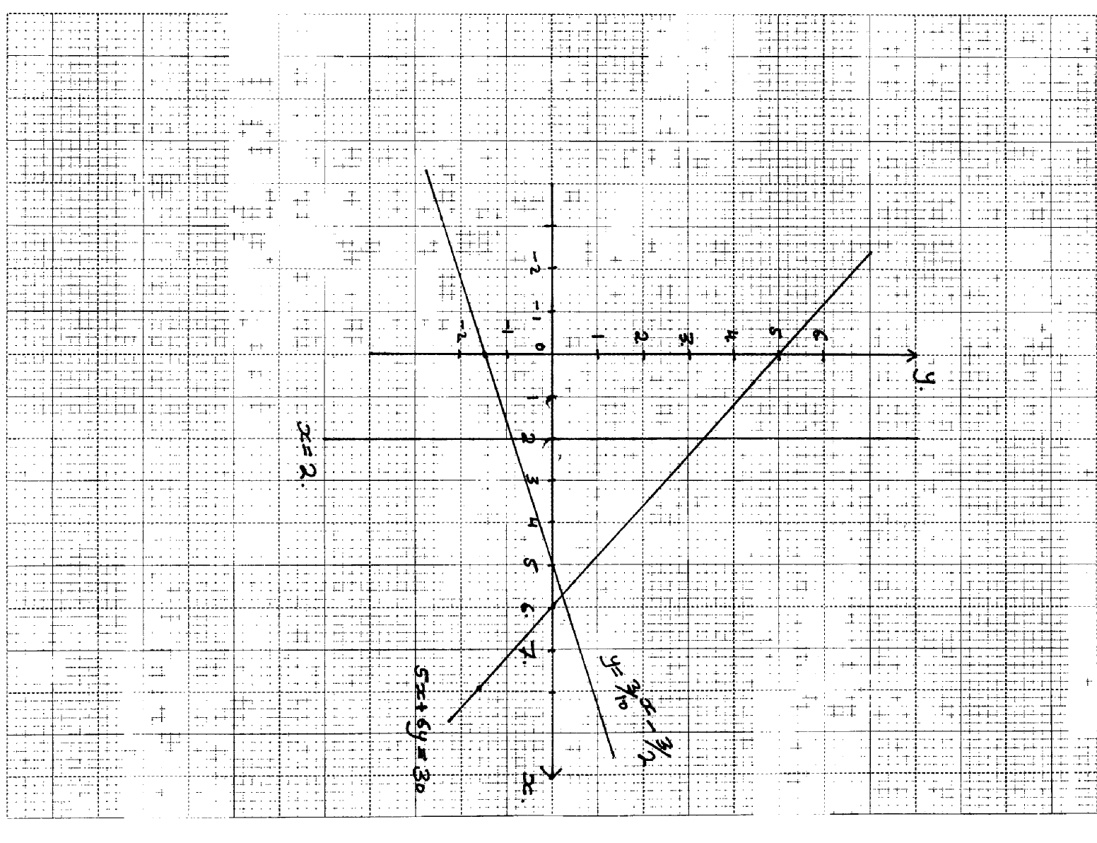
15. The diagram below shows the graphs of y = ³/₁₀ x – ³/₂, 5x + 6y = 3 and x = 2

By shading the unwanted region, determine and label the region R that satisfies the three
inequalities; y ≥ ³/₁₀ x – ³/₂,
5x + 6y ≥ 30 and x ≥ 2

16. The cost of 7 shirts and 3 pairs of trousers is shs. 2950 while that of 5 pairs of trousers and 3 shirts
is less by 200. How much will Dan pay for 2 shirts and 2 pairs of trousers?

17. Mr. Wafula went to the supermarket and bought two biros and five pencils at sh.120.
Whereas three biros and two pencils cost him sh.114. Find the cost of each biros and pencils

18. A father is twice as old as his son now. Ten years ago, the ratio of their ages was 5:2.
Find their present ages

19. List the integral values of x which satisfy the inequalities below:-
2x + 21 > 15 – 2x ≥x + 6

20. Find the equation of a line which passes through (-1, -4) and is perpendicular to the line:-
y + 2x – 4 = 0

21. John bought two shirts and three pairs of trousers at Kshs. 1750. If he had bought three shirts
and two pairs of trousers, he would have saved Kshs. 250. Find the cost of a shirt and a trouser.

22. Express the recurring decimal 3.81 as an improper fraction and hence as a mixed number
23. Karani bought 4 pencils and 6 biro pens for shs.66 and Mary bought 2 pencils and 5 biro
pens for shs.51
(a) Find the price of each item
(b) Ondieki spent shs.228 to buy the same type of pencils and biro pens. If the number
of biro pens he bought were 4 more than the number of pencils, find the number of
pencils he bought

24. Two consecutive odd numbers are such that the difference of twice the larger number
and twice the smaller number is 21.Find the product of the numbers

25. The size of an interior angle of a regular polygon is 3xº while its exterior angle is (x-20)^{o.}
Find the number of sides of the polygon

26. Five shirts and four pairs of trousers cost a total of shs.6160. Three similar shirts and
a pair of trouser cost shs.2800. Find the cost of four shirts and two pairs of trousers

27. Two pairs of trousers and three shirts costs a total of Shs.390. Five such pairs of trousers and two shirts cost a total of Shs.810. Find the price of a pair of trouser and a shirt

